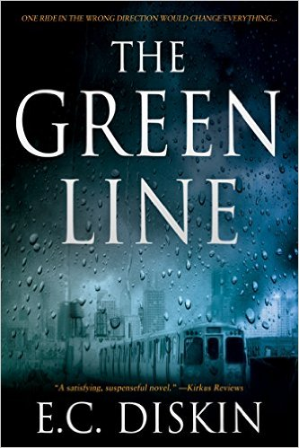
The Green Line
One Ride in the wrong direction would change everything.
Abby Donovan’s decade-long dream of partnership at her prestigious Chicago law firm is just months from fruition. But it’s all about to change because of one misstep.
One step onto a late-night train headed in the wrong direction. Headed into Chicago’s west side, where gangs and violence and drugs fill the streets.
In this engaging debut, E. C. Diskin, a former Chicago attorney, takes us on a fast-paced thrill ride with a believable and flawed heroine. Readers will relate to her, fear for her, and get a glimpse inside Chicago’s best and worst. From the roughest streets of the west side to the estates of the North Shore, Abby Donovan and the unexpected villains of The Green Line will keep you turning pages late into the night as they shine light on a little-known, often-used, and widely-abused legal maneuver.

Title: The Green Line
Author: E. C. Diskin
Category: Legal Thriller
ISBN: 978-1477818404
Format: Paper, audio, e-book
Publisher: Thomas & Mercer
Pub Date: 11-26-13
Pages: 323
Price: 14.95/3.99 /14.95
Available from: Brilliance
Publishing & Ingram
Translations: German
Reach: Over 100,000 readers and counting
CONTACT: David Hale Smith, Inkwell Mgmt.,
(212) 922-3500
dhs@inkwellmanagement.com

The Reviews: “A fast, fascinating read…with riveting characters,
a nuanced plot, and an insightful and interesting look at the practice of law
in today’s America.” Windy City Reviews

With well-drawn characters…knotty and believable puzzles, [and] an easy,
confident writing style…Diskin’s debut … is a satisfying, suspenseful novel
with an engaging heroine.” Kirkus Reviews

“Diskin’s writing is fast paced, carefully researched, and driven by a complex
plot, nonstop suspense, and page-turning action.” Reader Views

“The writing is believable and strong…[t]he reader is pulled through at
a startling pace… [and the] ending will leave your thriller thirst quenched
and satisfied.” Chicago Book Review

About the Author: This mega-selling author and former attorney is a compelling storyteller. In The Green Line, she dives into police corruption and widely abused civil forfeiture laws. John Oliver also exposed forfeiture’s twisted uses in “Last Week Tonight.” His segment has now been viewed 11 million times on YouTube, demonstrating the timeliness and relevance of The Green Line’s subject matter. Diskin’s second book, Broken Grace, is an international bestselling psychological thriller and her third, Depth of Lies, peels away the facades of marriage and suburbia. With her latest, Desperate Paths, she tackles the collateral damage of sexual predators, covert racism, and the meaning of justice through captivating characters and shocking twists. With several translations and numerous best-seller lists under her belt, she’s quickly gaining attention as one to watch. Rick Kogan, of Chicago Tribune and WGN Radio has called her “a thrilling new voice on the literary landscape.”

