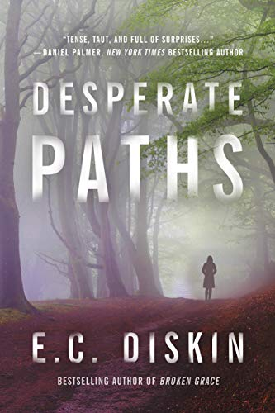
DESPERATE PATHS
She knew everything about her family and her town. Except its secrets.

The Reviews:
“[A] riveting, powerfully told story of faith, family and long-buried secrets that
had me guessing again and again… Don’t miss this one!”
Daniel Palmer, NYT Bestselling author

“Shocking, suspenseful, and high relevant…you’ll be thinking about it
long after you turn the last page.”
Laura McHugh, Int’l Bestselling author of Weight of Blood

“A tightly plotted thriller wrapped around a heartfelt small-town drama…[it’s] as wise as it is thrilling, a mystery about what the word ‘family’ really means.”
Amy Gentry, Int’l bestselling author of Good as Gone

“Emotionally moving while also page-turning, this book has all you need.”
Shannon Kirk, bestselling author of Method 15/33

Title: Desperate Paths
Author: E. C. Diskin
Category: Mystery/Thriller
ISBN: 978-1542040334
Format: Paperback, audio,
e-book
Publisher: Thomas & Mercer
Pub Date: 03-19-19
Pages: 340
Price: 15.95/14.99/4.99
Trim: 5.5 x 8.2 in/1.1 lbs
Available from: Brilliance
Publishing & Ingram
Marketing Plans:
Targeted print and internet media, internet advertising, direct mail & email marketing, social media

Brooklyn Anderson knows it looks bad. She was found wiping down a gun. His blood on her hands. Her father now dead. The incomprehensible nightmare has started.
Seven days earlier, Brooklyn had returned to Eden to care for her beloved father, who lay helpless in a hospital bed. Her estranged sister, Ginny, said he fell. But as Brooklyn soon realizes, Ginny is prone to lying.
Former Eden resident, Darius Woods was in the hospital too. The famous actor had written a screenplay that would lay bare all the secrets of the town, but within hours of his return, someone shot him.
As the Woods investigation proceeds, and Brooklyn starts to question everything she believes about her family, her neighbors, and her home, secrets and lies begin to unravel. But nothing can prepare her for where those lies will finally lead.
And sharing the truth of what happened the night her father died might just make things worse.

truth of what happened the night her father died might just make things worse.

About the Author: This mega-selling author and former attorney is a compelling storyteller. With each novel, Diskin writes mesmerizing page-turners that don’t let go. She dove into police corruption and the widely abused civil forfeiture laws with her debut, The Green Line, took on mental illness in Broken Grace, and exposed the facades of marriage and suburbia in Depth of Lies. With Desperate Paths, compelling characters pull the reader along for a shocking and twisted tale of secrets and lies while wading through the hot-button issues of sexual predators, covert racism, and the meaning of justice in America. With several translations of her work and numerous best-seller lists under her belt, she’s quickly gaining attention as one to watch. Rick Kogan, of Chicago Tribune and WGN Radio has called her “a thrilling new voice on the literary landscape.”
For media kit, see http://www.ecdiskin.com/media-kit.html
Agent: David Hale Smith, Inkwell Management (212) 922-3500 dhs@inkwellmanagement.com

