DESPERATE PATHS
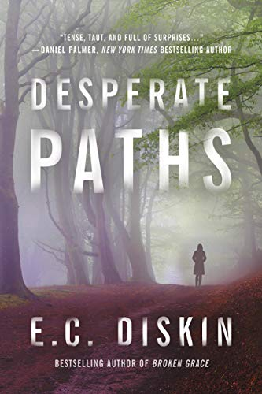
Author: E. C. Diskin
Agent: David Hale Smith, Inkwell Management
Publisher: Thomas & Mercer
Publicity: Brandon McGill, Wells Street PR
Pub date: March 19, 2019
Genre: Thriller/Mystery
Formats: Paperback, Audio, E-book
Price: 15.95/14.99/4.99
Pages: 340 pgs

Quotes from text:
(Chapter One--Brooklyn)
In seven days, she’d gone from strolling through New York’s Central Park to being locked inside a jail cell in Boline County, Illinois. Seven days. Her mom used to say that if an entire world could be created in seven days, there was no better number.
But it was just another of Mom’s lies.
***
(Chapter Six--Ginny)
The wheels were in motion, the police investigation into Darius’s shooting was national news, John might even start rambling. The truth was coming. This beautiful home, this family—it was all her kids had ever known, and it was about to disappear. Like a strobe light of torture, she was hit with images from the night before: blood, rain, EMTs loading bodies into ambulances.
Her world was spinning out of control, and she didn’t know how to stop it.
***
(Chapter Nine–Brooklyn)
Dad had always said desperate people were the most dangerous.

***

(Chapter Twelve –Ginny)
She’d heard “the truth will set you free” a million times in church, but it wasn’t true. The truth would destroy them all… She imagined the whispers, the stories, the gossip that would spread… She sat up and crawled toward the ledge. The vodka made her feel wobbly, and she collapsed onto her stomach, inching herself forward until only her head dangled over the cliff. She couldn’t see past the treetops below. Would they stop a body, catching it like some rough nest, or would someone simply crack branches and break bones the whole way down? She took her bottle, half-empty now, and opened her grasp, watching it fall, waiting, listening.
Death would be painful, she realized, but swift.
***
Longer Excerpt from Chapter Four:
The TV hanging in the corner was muted. Brooklyn found the remote and turned up the volume. E! News was on. Growing up, she’d never been allowed to watch celebrity news shows. Dad would walk in to the family room, overhear some bit about a pregnancy or a Kardashian breakup, grab the remote, and shut it off. “Gossip is the devil’s radio, baby. Don’t be his DJ,” he’d say. She wanted to point out that listening wasn’t really being a DJ but never dared. Instead, she’d say, “Yes, sir.” She never talked back. Her parents deserved one easy kid.
But she and her roommates watched all the time—it was news of her industry, after all.
The glamorous host reported on the biggest-grossing movies of the weekend and then switched stories, her expression becoming more serious, while a picture of the actor Darius Woods appeared in the upper right corner of the screen. “Darius Woods remains in critical condition at a hospital in southern Illinois today,” she reported. Brooklyn’s spine straightened like a rod. The image on the screen switched to a picture of the hospital. It was this hospital. Here. Darius Woods was here. She looked around the empty room as if to say, “Do you hear this?” to whomever she could find.
“The actor was visiting his father at the time of the shooting,” the host continued. “No other details have been released at this point. The Boline County Sheriff’s Office is investigating.”
As the show moved to another topic, Brooklyn remained fixated on the screen, stunned. So that’s why there were all those media trucks in the parking lot. Everyone in Eden knew the name Darius Woods. In the summer before Brooklyn’s junior year, Unbound came out, a sleeper hit with Woods in a main role. Suddenly, his face was on magazine covers, and photos from his roles in Eden High School drama productions were on permanent display in the school. College graduates and success stories were rare enough, but a true celebrity from Eden was unheard-of. Then in January, he got an Oscar nomination for his latest role, and reviewers, in typically superficial style, started calling him the next Denzel. He made the dream seem possible. It didn’t matter that Eden was Small Town, USA, or that Brooklyn had no contacts, agent, or experience beyond high school: Darius Woods had proved that miracles happened.
She couldn’t imagine who would shoot him. He hadn’t even lived there in twenty years. She wondered if this was what fame did, or if some old enemy begrudged his success. Vendettas were the stuff of local legend. Her history teacher used to tell them all sorts of crazy stories. And of course, she’d heard about violence in the county from her parents and the sheriff—the robberies and bar fights that turned deadly, drug-fueled crimes in neighboring towns. It never sounded all that surprising with more gun shops than grocery stores—but she’d always thought Eden was relatively safe.
Of course, Boline County did have its share of racists. She’d certainly seen plenty during high school football games, when her school would play against a more racially diverse team, or when she’d eavesdrop on whispered conversations in her all-white church that sounded a little too like the 1950s. There was no denying the undercurrent, the invisible lines, whether in the lunch room or on the bleachers. Eden was probably ninety-seven percent white, two percent black, and a few “others.” Everyone stayed with their own—except Brooklyn, who didn’t quite fit anywhere.
***

